[Your organization Name]
Microsoft Cloud Adoption Plan
[Date]

Executive Summary
[Overview of your business priorities, timelines and milestones in the upcoming year for successful cloud adoption. Also include prioritized projects and criteria for such projects.]

Define Strategy
Motivations and drivers
Why do you want to adopt the cloud? Are there critical business events driving your decision? Do you have specific business motivations?
[Understand and describe business situation, implications and details on business events driving the move to the cloud]

Business outcomes
What are the expected business outcomes from adopting the cloud? Collect them in the corresponding table below, organized by priority.
High Priority
Stakeholder: |  |  |  | Outcome:
Business Drivers |  |  |  | KPI |  | Capabilities
List any business drivers |  |  |  | List success metrics |  | List necessary capabilities

Mid Priority
Stakeholder: |  |  |  | Outcome:
Business Drivers |  |  |  | KPI |  | Capabilities
List any business drivers |  |  |  | List success metrics |  | List necessary capabilities
Low Priority
Stakeholder: |  |  |  | Outcome:
Business Drivers |  |  |  | KPI |  | Capabilities
List any business drivers |  |  |  | List success metrics |  | List necessary capabilities

Business justification
How would you measure success? Beyond achieving the business outcomes, are there other indicators for successful Azure adoption in your organization?
Consider creating a business case for adopting Azure and create a financial model to support this plan.

First adoption project
The first adoption project should align with the motivations behind cloud adoption. Whenever possible, the first project should also demonstrate progress towards a defined business outcome.
From the motivations and drivers identified, look for projects that could address those quickly. For example:
- If the main adoption motivation is to respond to a critical business event, consider implementing Azure Site Recovery and set it up as a disaster recovery tool for the first project to quickly reduce current dependencies within the datacenter.
- If a server migration is the main driver, consider starting with the migration of a noncritical workload and leveraging the Azure Readiness Guide and the Azure Migration Guide as guidance for the migration of that first workload.
- If main driver is to innovate o modernize current application, consider creating a targeted dev/test environment for your application.
Log your first adoption project in here:
Project: |  |  | Outcome:
Stakeholder: |  |  | Business Unit:

Key stakeholders
Who are the individuals within your organization whose participation is critical for the success of this adoption plan? Collect all key individuals in here, and mark who should be part of the Cloud Strategy Team in the table below. The Cloud Strategy Team is responsible for leading the cloud adoption within your organization, supporting all business outcomes, people and processes changes and technical projects identified within this plan.
Name | Business Unit/Role | Business Outcome Owner (Y/N) | Cloud Strategy Team (Y/N)

Consider working with a Microsoft Partner to help you navigate your cloud adoption journey. Find specialized partners here.
Plan
Digital estate
How would you evaluate current technology assets as you prepare for cloud adoption?
Start with gathering this information across the organization, and aggregating it in the following tables. At the same time, consider what is the best approach to move or modernize these to the cloud, considering the 5 Rs of rationalization. Always consider take an ‘incremental’ approach in this journey, meaning don’t try to list all your targets in your first attempt but grow them over time as you revisit this plan.
Migration targets: leverage migration examples that can help you create a centralized list of all VMs and servers.
Application/Workload | Business Unit | Business Priority (high, mid, low) | Proposed Rationalization

Innovation targets: opportunities to improve your customer experience, opportunities to innovate.
Application/Workload | Business Unit | Business Priority (high, mid, low) | Proposed Rationalization

Organizational alignment
How to ensure your organization is aligned and ready for Azure adoption? It’s critical to align people to capabilities needed to adopt Azure. Complete the following table with the people in the organization, mapping to specific capabilities:
Name of people responsible for…
Delivering technical tasks | Implementing cloud governance

This people will work aligned with the Cloud Strategy Team identified earlier in the Strategy phase.

Skills readiness plans
For successful cloud adoption, it’s critical to ensure your people, IT and non-IT, are ready for this transformation. Including in the table below, the key courses your organization needs to take for this process.
Course name | Audience (Cloud Architect, IT, Admin, Ops) | Level  (100, 200, 300, 400) | Source  (MS Learn, Pluralsight, ESI) | Priority  (high, mid, low)
Microsoft Cloud Adoption Framework for Azure | Admin, Devs, Cloud Architect, Business User, Cloud Engineer | 100 | MS Learn | High
Azure Fundamentals | Admin, Devs, Cloud Architect, Business User, Cloud Engineer | 100 | MS Learn | High
Learn the Business Value of Azure | Business User | 100 | MS Learn | Mid

Suggested skills are included in here, and more information on available, free, on-demand Azure technical readiness at MS Learn.
Cloud Adoption Plan
Cloud adoption plans convert the aspirational goals of the cloud adoption strategy into an actionable plan. The collective cloud teams can leverage the cloud adoption plan to guide technical efforts, in alignment with the business outcomes.
Your organization’s cloud adoption plan is here. You have identified the business drivers for this transformation. You have a financial understanding of the impact of this decision. You have completed an initial analysis to your current workloads, assets and applications to identify their path to the cloud. Your people is ready or aligned to a plan to get ready.
Now, let’s get ready for starting the initial implication conversations within your organization. Consider leveraging Azure DevOps to log and track your projects for cloud adoption and create a timeline for these projects, and others to come, to materialized.

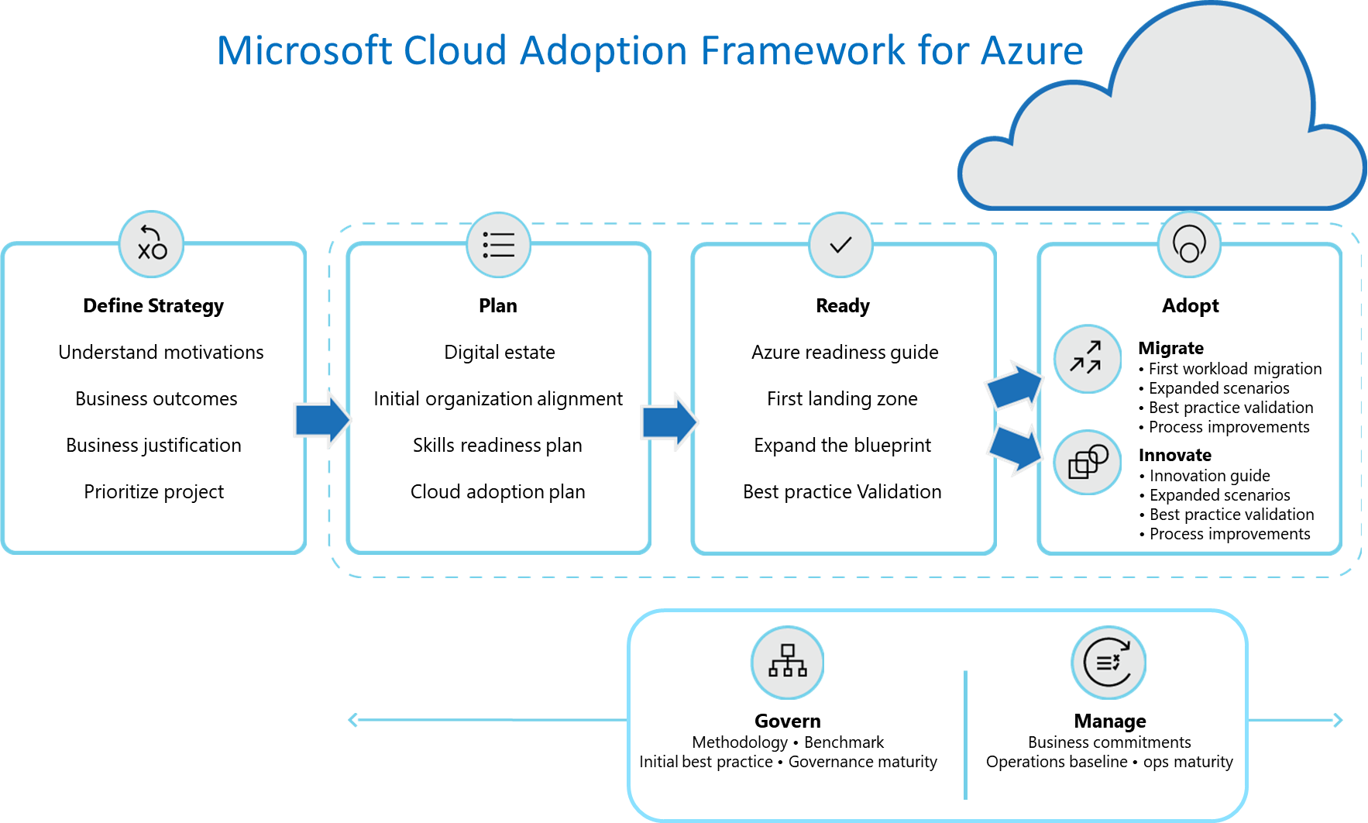

https://aka.ms/cloudadoptionframework

